

**Visual Basic.Net**

**AAPP008-4-2**

**GROUP ASSIGNMENT**

Name : NG HO KIT (TP035012)

ONG SHIN YEE (TP035399)

LIM CHUEN HUEY (TP034543)

Intake Code : UCDF1405ICTSE

Course Code : AAPP008-4-2

Lecturer Name : Kadhar Batcha Nowshath

Due Date : 6th November 2015

Table of Contents

1.0 Introduction 3

2.0 Screen Designs 4

2.1 Input Screen Designs 4

2.1.1 Login Page 4

2.1.2 Menu Page 5

2.1.3 Add 6

2.1.4 Remove 7

2.1.5 Update 7

2.1.6 Search 8

2.1.7 Transfer 9

2.1.8 Payment History 10

2.1.9 Make Payment 11

2.1.10 Report 12

2.2 Output Screen Designs 13

2.2.1 Login Output 13

2.2.2 Add Member Output 13

2.2.4 Update Data Output 14

2.2.5 Search Output 15

2.2.6 Transfer Output 15

2.2.7 Payment History Output 16

2.2.8 Make Payment Output 16

2.2.9 Report Output 17

3.0 User Manual 18

3.1 Login 18

3.2 Log Out 20

3.3 Menu - Add member 20

3.4 Menu - Remove 22

3.5 Menu – Update 23

3.6 Menu - Search 25

3.7 Menu – Transfer 26

3.8 Menu - Payment History 28

3.9 Make A Payment 29

3.10 View All Member 31

3.11 Report 32

4.0 Critical Assessment 34

4.1 Strength of Our System: 34

4.2 Weakness of Our System: 34

4.3 Recommendations 35

5.0 References 36

# 1.0 Introduction

Imperial Golf Club is one of the most exclusive clubs in Kuala Lumpur. However, due to the increasing number of club members, a system is much needed to improve their management. Thus we will create a system for Imperial Golf Club.

Our scope in creating this system is to enhance the management of the targeted golf club. We are sure that the new system will bring in easier management of data and it can prevent the loss of data.

The system will have the features of:

* Adding members
* Remove members
* Update member’s profile
* Search member
* Transfer membership
* A payment system
* Generate reports

Our objectives for the new system are to

* Have a user friendly system for the administrator of the company
* Have a database connected to the system to store the data of the customers

# 2.0 Screen Designs

## 2.1 Input Screen Designs

### 2.1.1 Login Page

|  |
| --- |
| * × |
| User Login – Imperial Golf Club |
| Textbox 1  Textbox 2  Button 1  Button 2  Picture Box |

* Textbox 1: To insert username
* Textbox 2: To insert password
* Button 1: Login
* Button 2: Reset
* Picture Box: Logo

### 2.1.2 Menu Page

|  |
| --- |
| * □ × |
| Menu Button 01 |
| Tab Control (Tab Page 1 - 6) |
|  |

* Button 01: Log Out
* Tab Control:

*TabPage1: Add *TabPage4: Search

*TabPage2: Remove *TabPage5: Transfer

*TabPage3: Update *TabPage6: Payment History

|  |
| --- |
| Radio 1  Radio 2  Radio 3  Textbox 2  Button 2  PictureBox  Button 2  Button 1  Label 1  Label 2  Label 3  Label 4  Label 6  Label 7  Label 8  Label 5  Textbox 1  Textbox 3 |

### 2.1.3 Add

* Label 1: Full name
* Label 2: Type of membership
* Label 3: Contact number
* Label 4: Email
* Label 5-8: display ‘ : ’
* Textbox 1: To insert full name
* Textbox 2: To insert contact number
* Textbox 3: To insert email
* Radio 1: To select ‘Deluxe’
* Radio 2: To select ‘Non-Deluxe’
* Radio 3: To select ‘Week-Day’
* Button 1: Add
* Button 2: Reset
* Button 3: Browse (To browse picture)
* PictureBox: Member’s Picture

### 2.1.4 Remove

|  |
| --- |
| Button  Textbox |

* Textbox: To insert the customer ID which wish to remove
* Button

### 2.1.5 Update

|  |
| --- |
| Button 3  Label 1  Label 2  Label 3  Label 4  Label 5  Label 6  Label 7  Label 8  Label 9  Label 10  Textbox 2  Textbox 3  Textbox 4  Textbox 5  Radio 1  Radio 2  Button 2  PictureBox  Button 1  Textbox 1 |

* Textbox 3: To enter full name
* Textbox 4: To enter contact number
* Textbox 5: To enter email
* Radio 1: To check “Active”
* Radio 2: To check “Closed”
* Button 1: Search
* Button 2: Update
* Button 3: Browse
* PictureBox: member’s picture
* Label 1: Member ID
* Label 2: Full name
* Label 3: Contact number
* Label 4: Email
* Label 5: Status
* Label 6-10: display ‘ : ’
* Textbox 1: To enter customer profile wish to update
* Textbox 2: To enter member ID

### 2.1.6 Search

|  |
| --- |
| Button 1  Textbox 1 |

* Textbox 1: To enter customer id
* Button 1: Search

### 2.1.7 Transfer

|  |
| --- |
| Button 3  Button 2  Label 6  Label 7  Label 3  Label 4  Label 2  Label 1  Label 8  Textbox 2  Textbox 3  Textbox 4  Textbox 5  Label 5  Picture Box  Button 1  Textbox 1 |

* Label 1: Name
* Label 2: Membership
* Label 3: Contact Number
* Label 4: Email
* Label 5-8: display ‘ : ’
* Textbox 2: To allow user to change the name
* Textbox 3: To display the membership type that will be transferred
* Textbox 4: To allow user to change the contact number
* Textbox 5: To allow user to change the email
* Button1: Confirm
* Button 2: Change
* Button 3: Transfer
* Picture Box: To display picture

### 2.1.8 Payment History

Textbox 1

|  |
| --- |
| List View 1  Column Header 1-9  Button 1  Button 2 |

* Button 1: Search
* Button 2: Make A Payment
* Textbox 1: To insert member ID to search
* Column Header 1: Payment ID
* Column Header 2: Member ID
* Column Header 3: Membership ID
* Column Header 4: Date Of Entry
* Column Header 5: Logged By
* Column Header 6: Description
* Column Header 7: Amount Due
* Column Header 8: Amount Paid
* Column Header 9: Payment Date
* List View 1: To display the payment history of the member

### 2.1.9 Make Payment

|  |
| --- |
| Label 17  Combo Box 2  Label 11  Label 12  Label 13  Label 14  Textbox 1  Group Box 2  Label 1  Label 2  Label 3  Label 4  Label 5  Label 6  Label 7  Label 8  Label 9  Label 10  Group Box 1  Label 16  Label 15  Combo Box 1  Button 2  Button 1 |

* Group Box 1: User Details
* Group Box 2: Payment Details
* Label 1: Name
* Label 2: Member ID
* Label 3: Membership ID
* Label 4: Date of Entry
* Label 5: Logged By
* Label 6: To display Customer’s Name
* Label 7: To display Customer’s ID
* Label 8: To display Customer’s Membership ID
* Label 9: To display Customer’s Date of Entry
* Label 10: To display the user that logged into the system
* Label 11: Description
* Label 12: Amount Due
* Label 13: Payment Date
* Label 14: Amount Paid
* Label 15: Display Amount Due
* Label 16: Display Payment Date
* Label 17: Month
* Textbox 1: To insert the amount paid
* Button 1: Pay
* Button 2: Cancel
* Combo Box 1:
* Item 1: Registration Fee
* Item 2: Monthly Fee
* Item 3: Transfer Fee
* Combo Box 2:
* Item 1: January
* Item 2: February
* Item 3: March
* Item 4: April
* Item 5: May
* Item 6: June
* Item 7: July
* Item 8: August
* Item 9: September
* Item 10: October
* Item 11: November
* Item 12: December

### 2.1.10 Report

ContextMenuStrip

|  |
| --- |
| * □ × |
| Menu Button 01 |
| Tab Control (Tab Page 1 - 6) |
| ContextMenuStrip 4  ContextMenuStrip 3  ContextMenuStrip 2  ContextMenuStrip 1 |

* Button 01: Log Out
* Tab Control:

*TabPage1: Add *TabPage4: Search

*TabPage2: Remove *TabPage5: Transfer

*TabPage3: Update *TabPage6: Payment History

* ContextMenuStrip1 :View Members
* ContextMenuStrip2 :Reports
* ContextMenuStrip3 :Member Reports
* ContextMenuStrip4 :Payment Reports

## 2.2 Output Screen Designs

### 2.2.1 Login Output

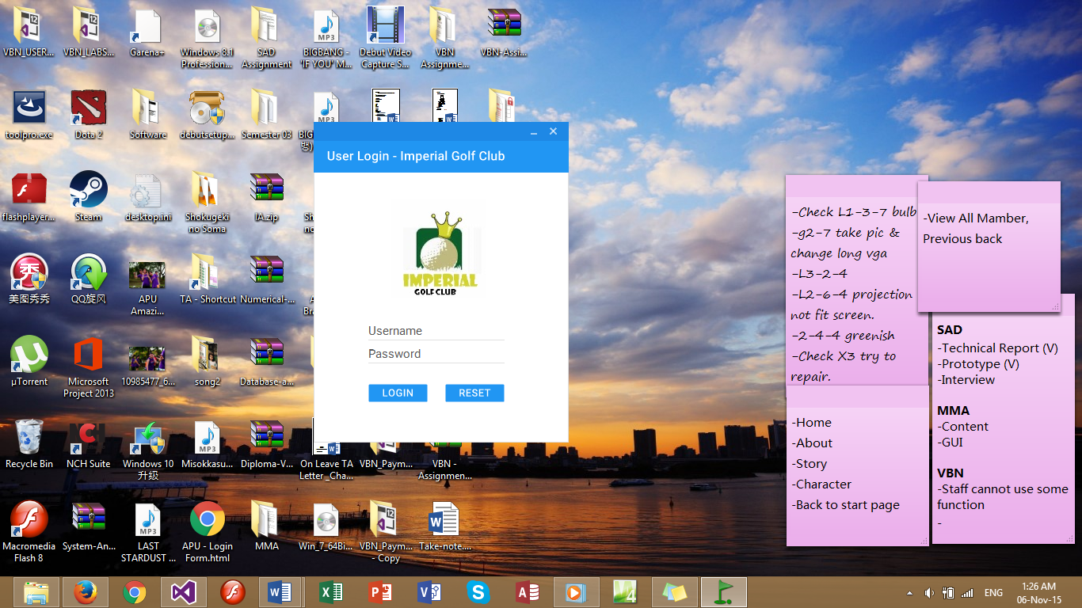

### 2.2.2 Add Member Output

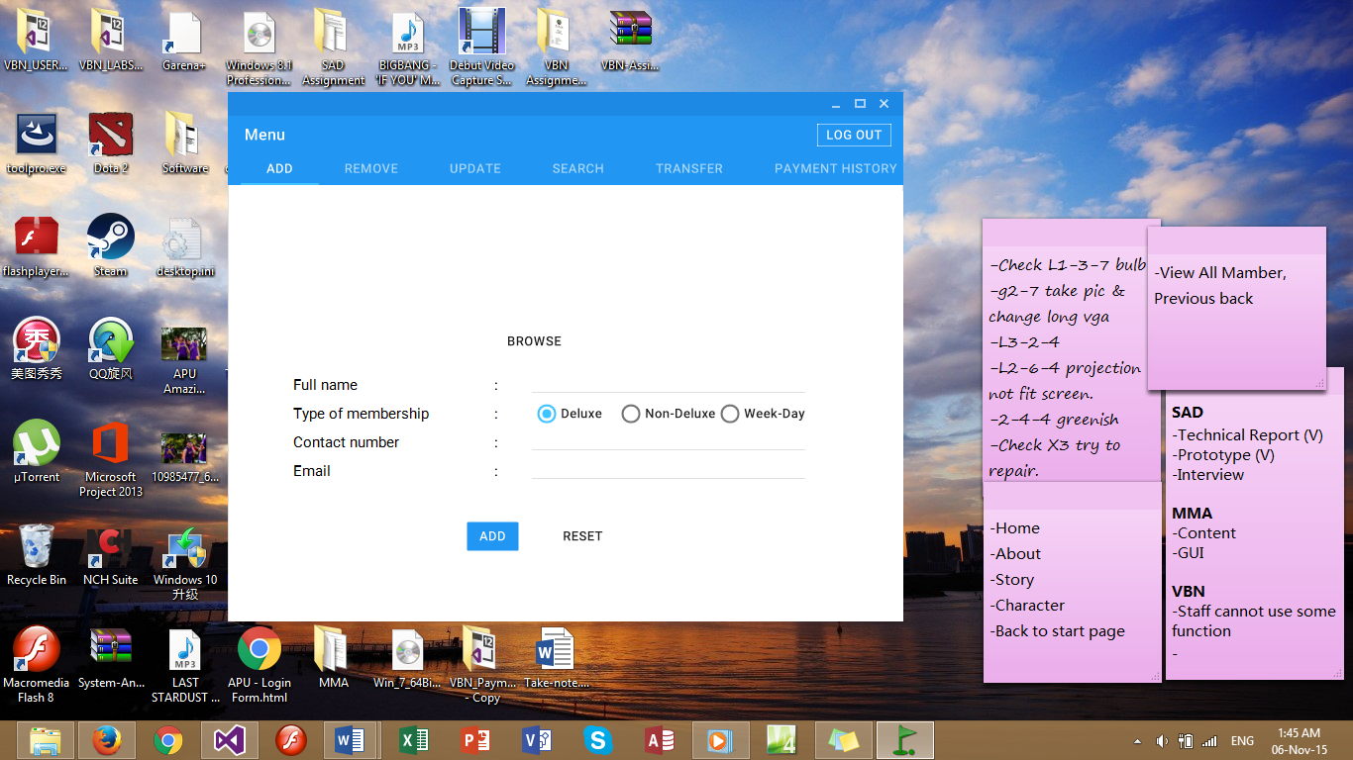

2.2.3 Remove Member Output

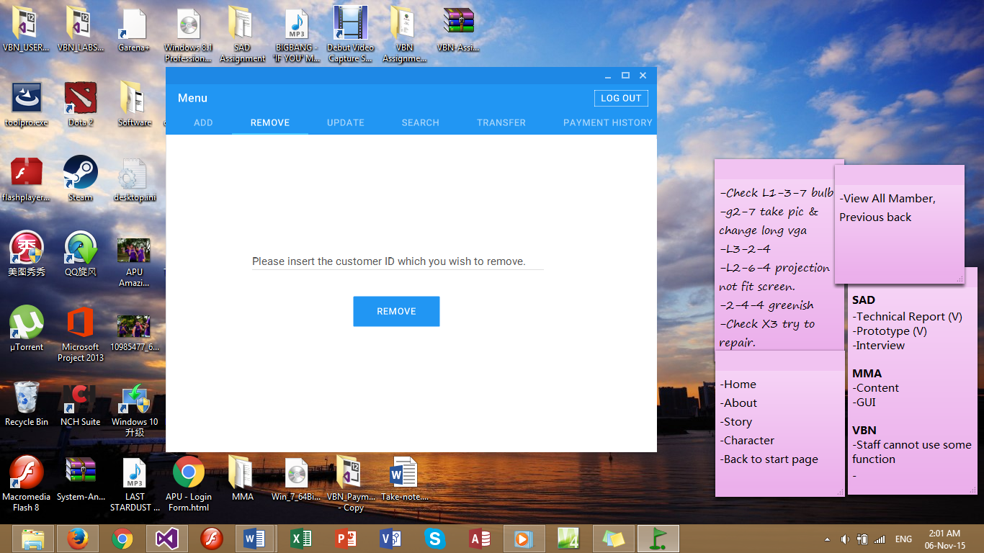

### 2.2.4 Update Data Output

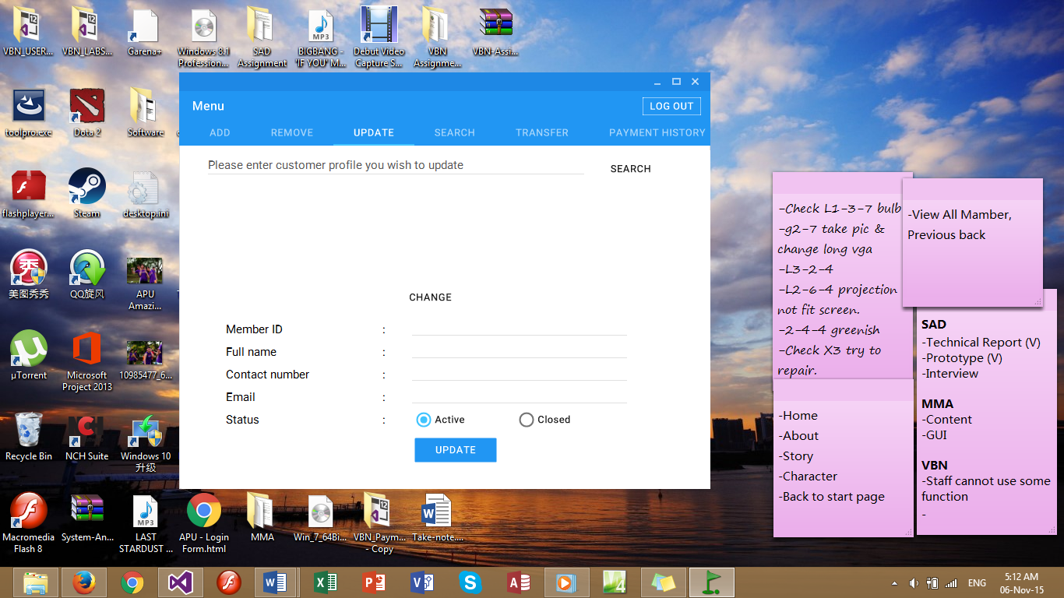

### 2.2.5 Search Output

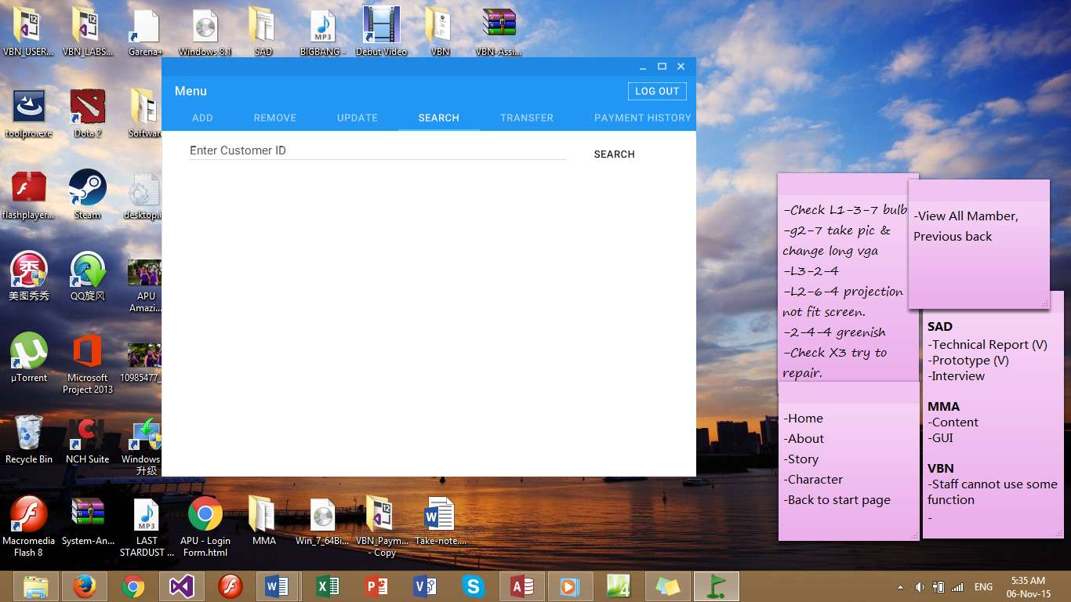

### 2.2.6 Transfer Output

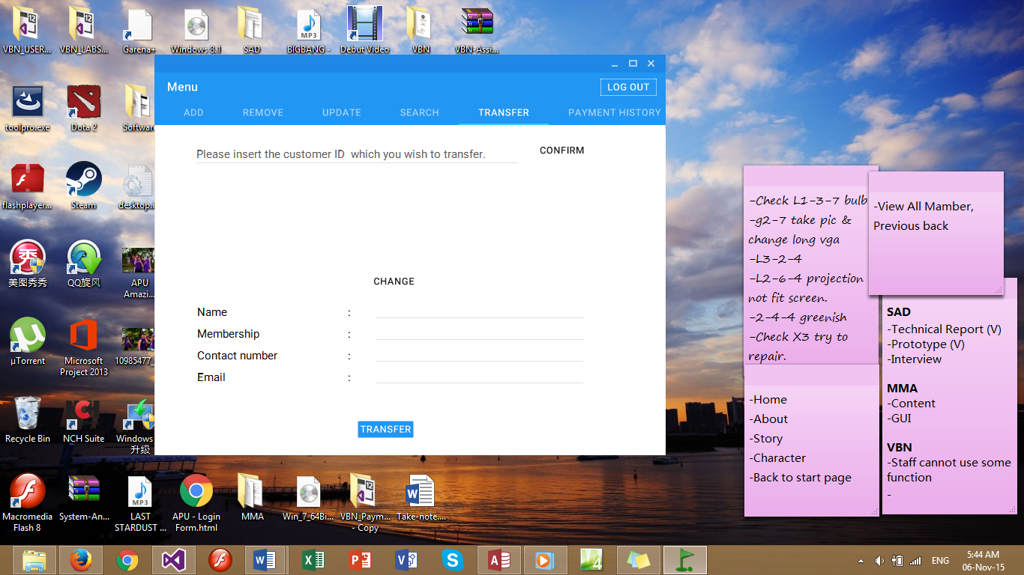

### 2.2.7 Payment History Output

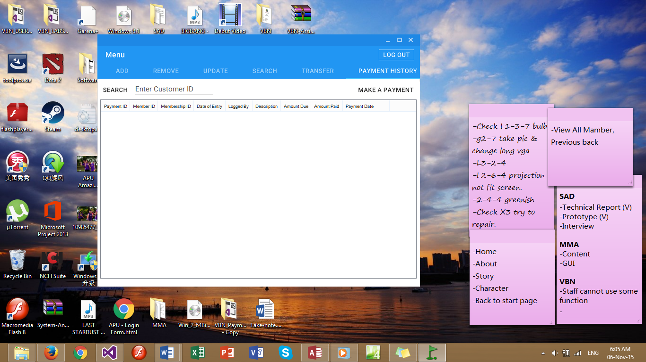

### 2.2.8 Make Payment Output

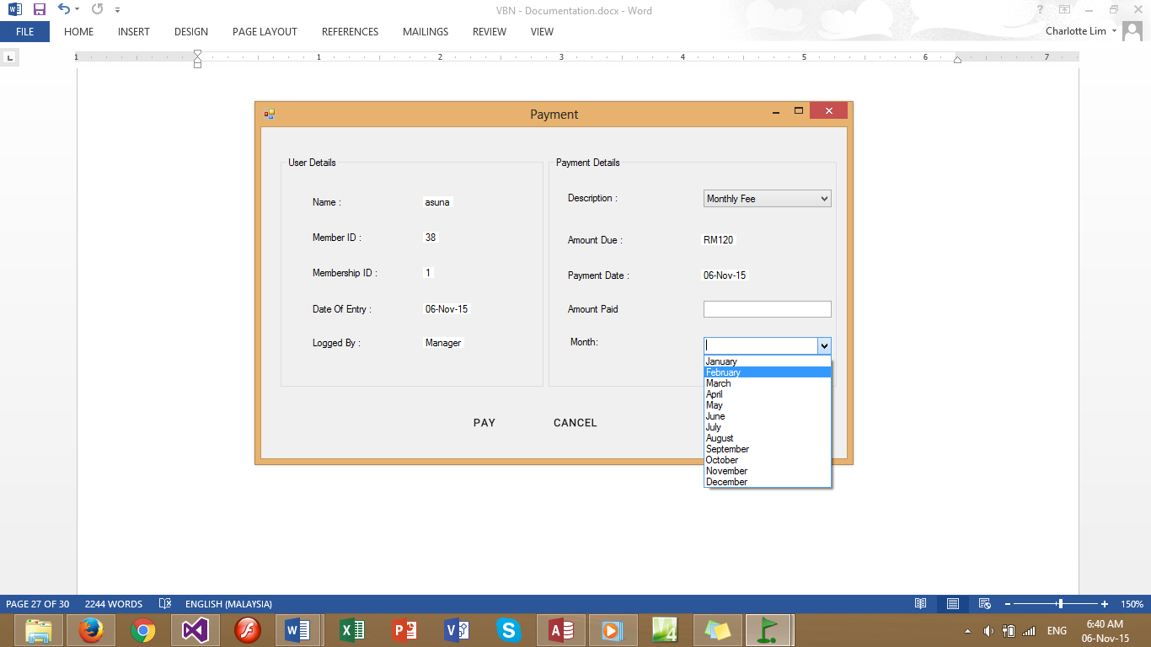

### 2.2.9 Report Output

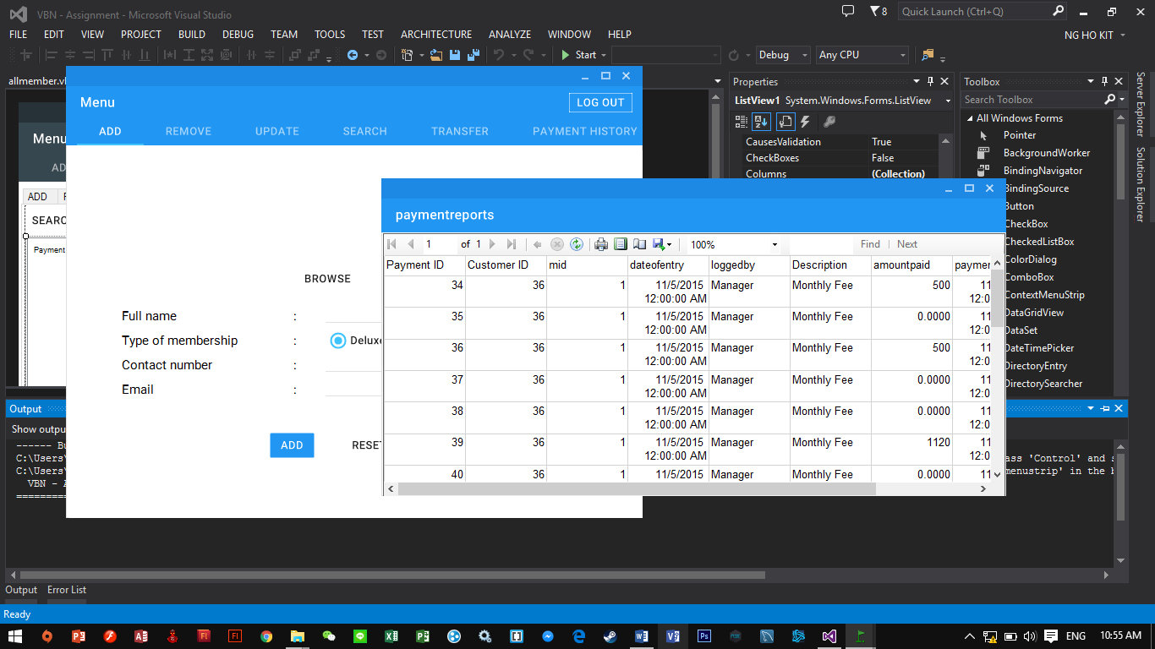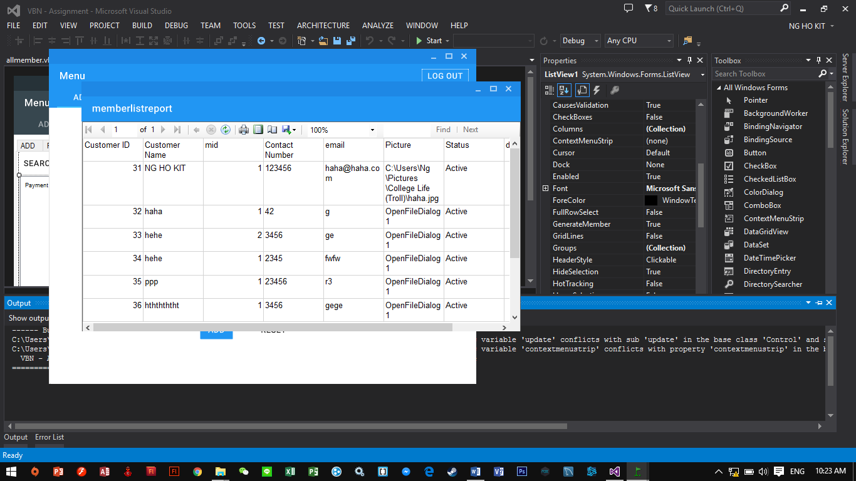

# 3.0 User Manual

## 3.1 Login



First of all, the user are required to enter username and password in order to log into the website. After inserting the username and password, user have to select the “Login” button in order to login to the system. However, if the users would like to reset the username and password they inserted, the can select the “Reset” button. When the user login successfully, a message box will pop out and greet the user depending on the user’s role (as shown in figure below). After the message box, the system will prompt out.

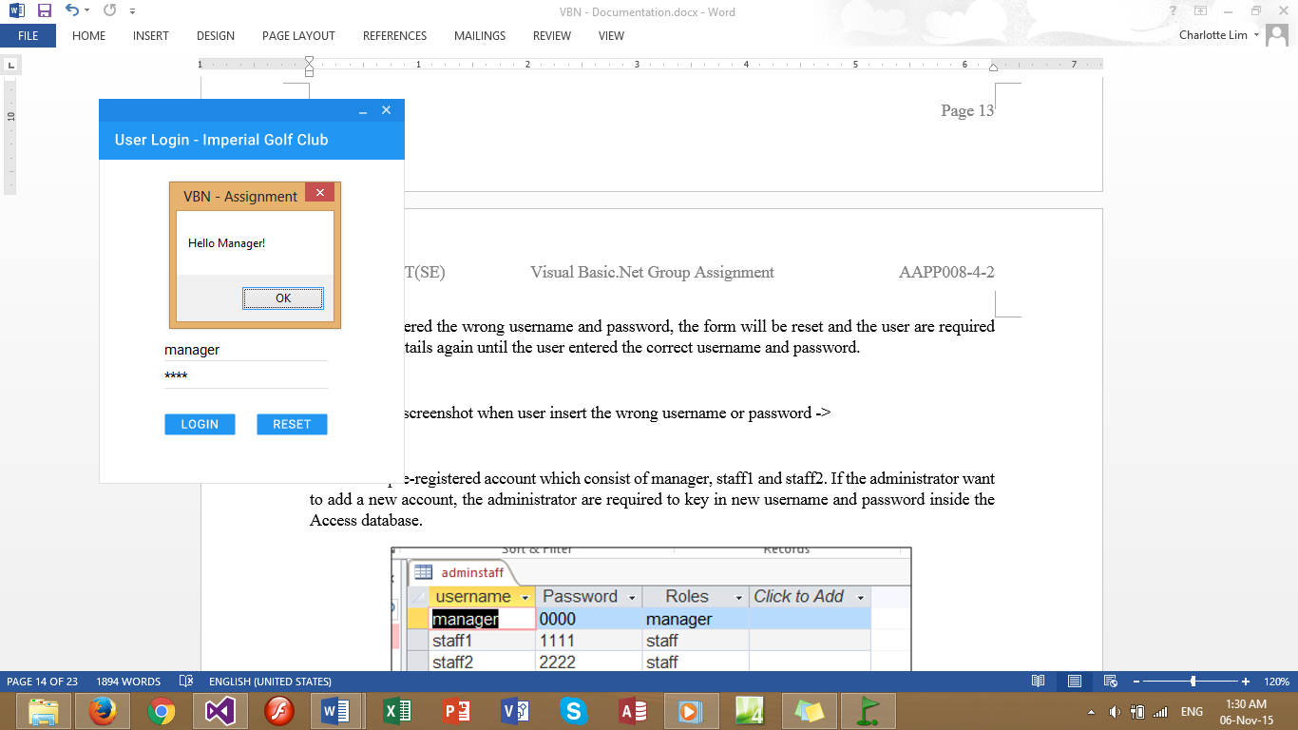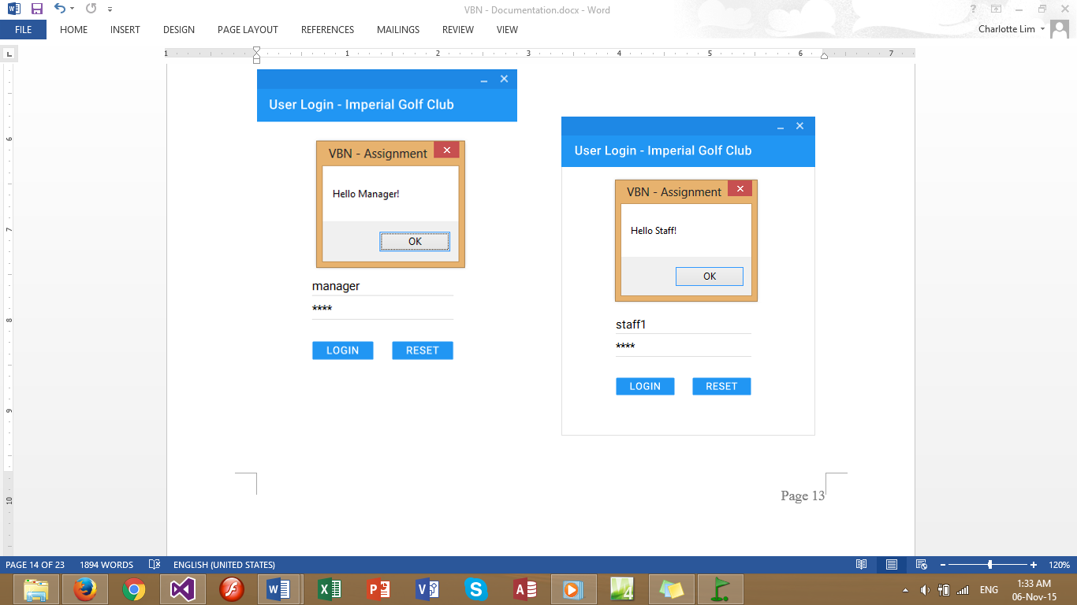

If the user entered the wrong username and password, the form will be reset and the user are required to enter the details again until the user entered the correct username and password (refer to the picture below).

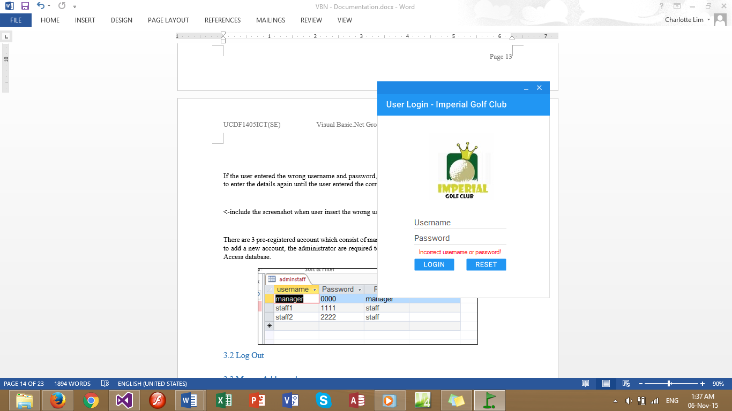

There are 3 pre-registered account which consist of manager, staff1 and staff2. If the administrator want to add a new account, the administrator are required to key in new username and password inside the Access database (as shown in the figure below).

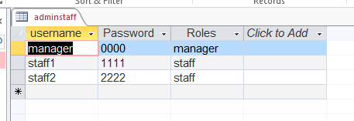

## 3.2 Log Out



When the user has done changing the settings in the system, users can log out the system by selecting the “Log Out” button as shown in the figure above. After selecting the button, the system will be back to the Login Page and other user can log into the system.

## 3.3 Menu - Add member



Figure above shows the “Add Member” page. This page allow the users to register new members. In order to register, the details of the new member has to be recorded into the system. When user selected the “BROWSE” button, a pop out window will appear and users are able to choose the picture of the member. After the picture is selected, it will be uploaded into the database as the member’s profile picture (as shown in the picture below).

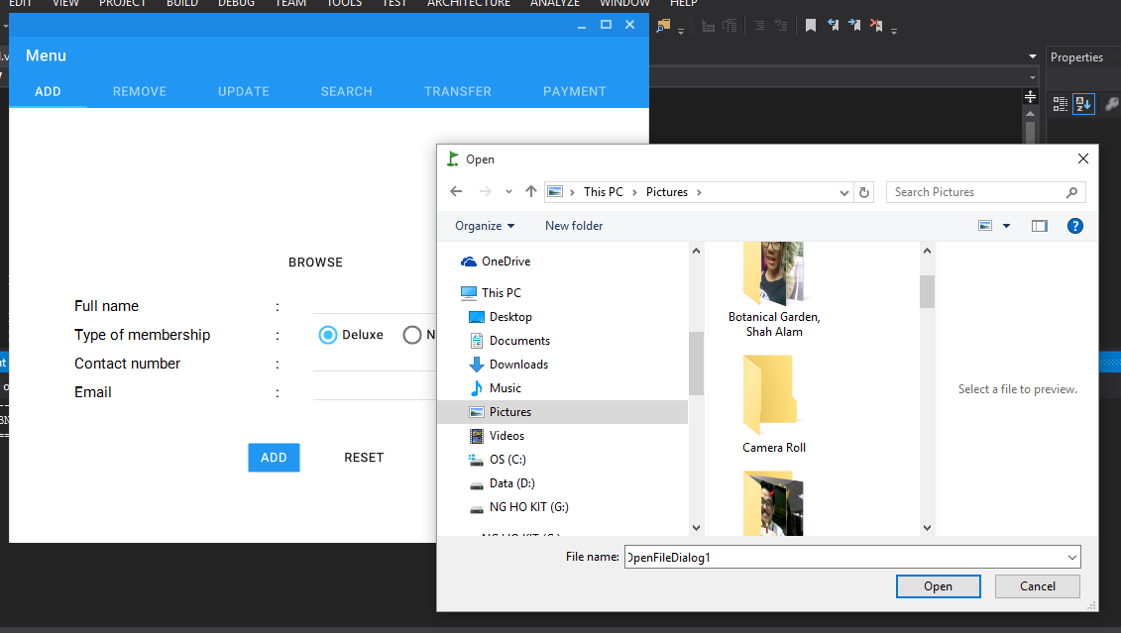

After that, users are required to enter the customer’s full name, type of membership that customers wish to register as, contact number and email. After the user enter every field, user should select “ADD” button. After that, a message box writing “Added!” will appear and all the data entered will be stored into the database. Once the user select “OK” button, the form will be reset, and user can register other new members.

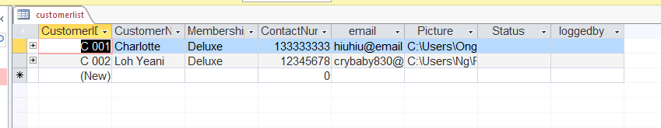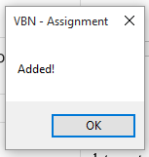

Users are not necessary to include every field in the textbox. But are highly recommended to fill all the field. As shown in the figure above, the data added from the system will be stored in the database.

## 3.4 Menu - Remove



In this form, users can just simply enter the customer ID and press “REMOVE” button in order to remove a specific member. After selecting the “REMOVE” button, a message box will pop up and ask whether if the users really want to remove the customer (as shown in the picture below).

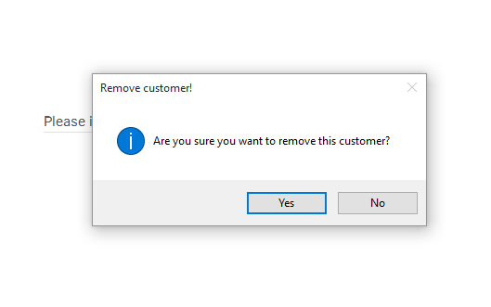

Once the user selected the “Yes” button the information about the customer will be removed permanently from the database.

## 3.5 Menu – Update



In this form, users are required to enter the customer ID of which customer who wish to update their personal information such as changing the contact number. First, users are required to enter customer’s customer ID at the search box, then the system will generate all the information of the customer. During this time, the Member ID and Full name textbox will be disabled which mean the user are unable to make any changes on it (as shown in the figure below).

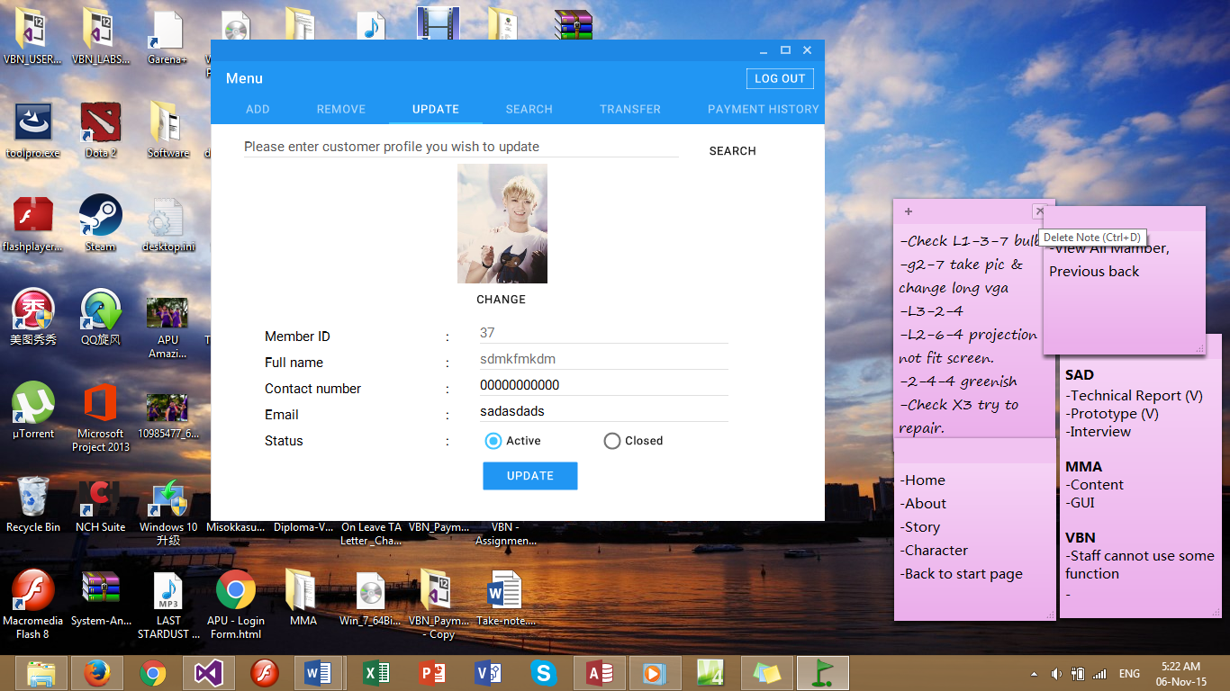

Once the user done making the changes, user need to press “UPDATE” button in order to update the customer details. After that, a message box will pop up and the customer details is successfully updated. In this form, user only can update customer image, emails, contact number and also status.

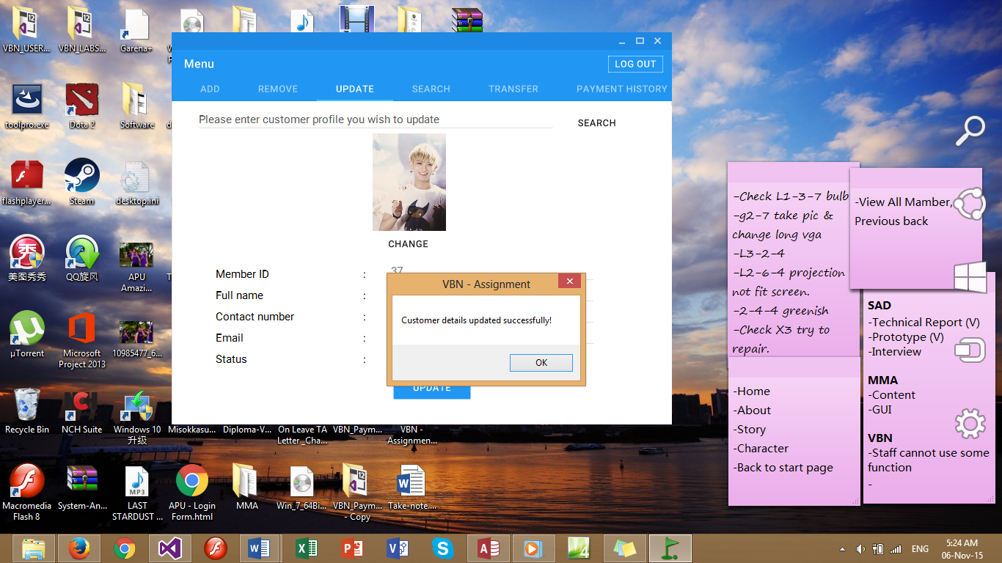

However, when users inserted a wrong information (such as member id that is not existed) into the search box and select “search” button, a message box will appear showing “No Such User” as shown in the figure below.

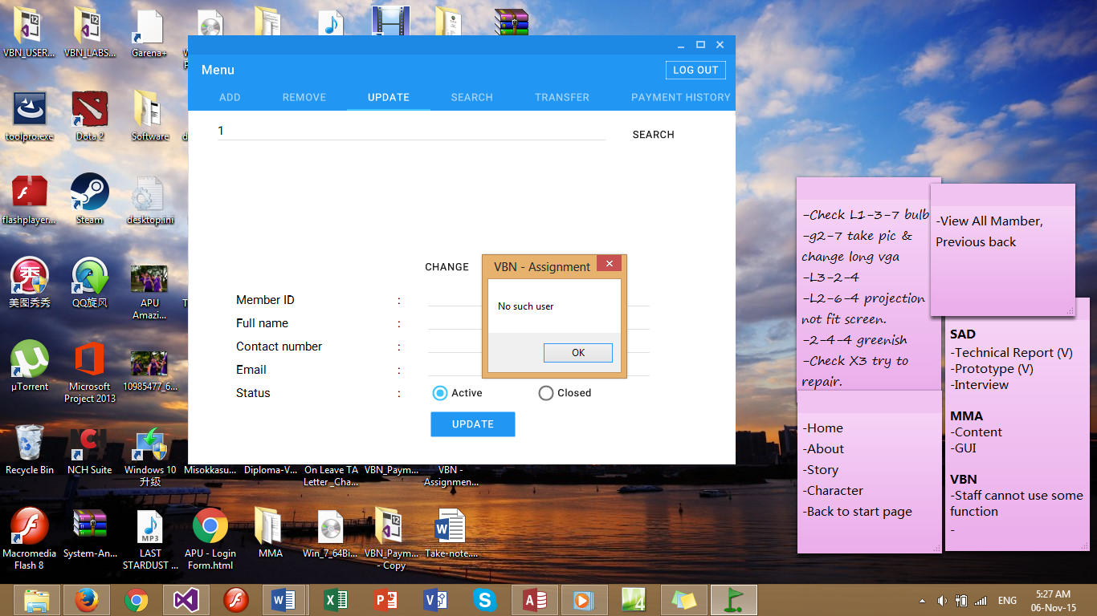

## 3.6 Menu - Search



In this form, when users want to search for a customer’s details, users are required to enter the customer ID. After entered customer ID, the information of the customer will appear (as shown in the figure below).

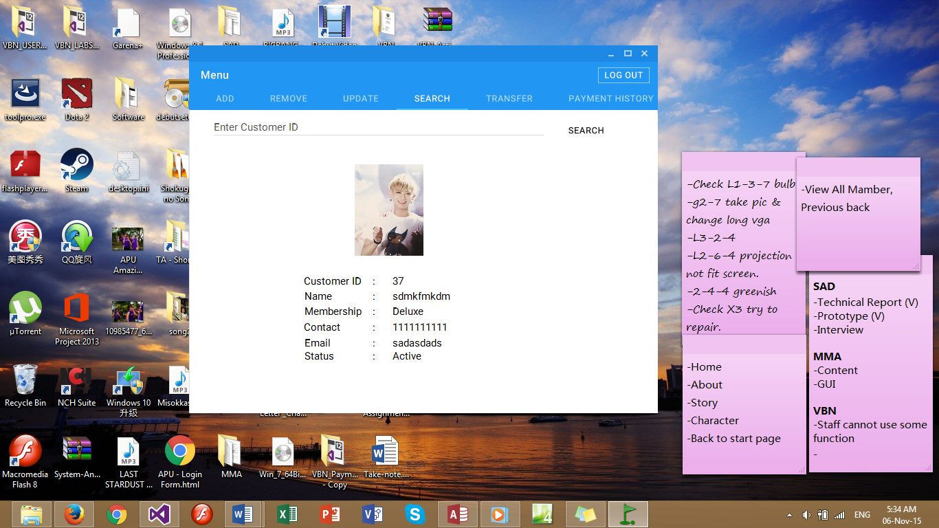

Meanwhile, when users had entered a wrong customer ID into the search box, a message box will appear with “No such user” (as shown in the figure below).

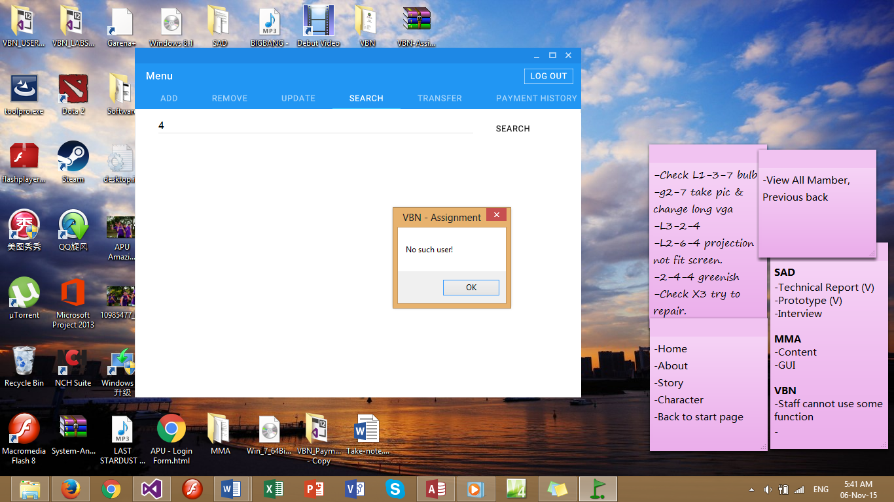

## 3.7 Menu – Transfer



Transfer is used when customers wants to transfer their membership to another customer. For example, Customer A wants to transfer his membership to Customer B. In order to apply the transfer, users have to insert the customer id of Customer A. After that, Customer A’s details will appear. Next, as shown in the figure below, users will insert the details of Customer B to replace the details of Customer A (except for the Type of Membership), then Customer B’s membership will be updated in the database.

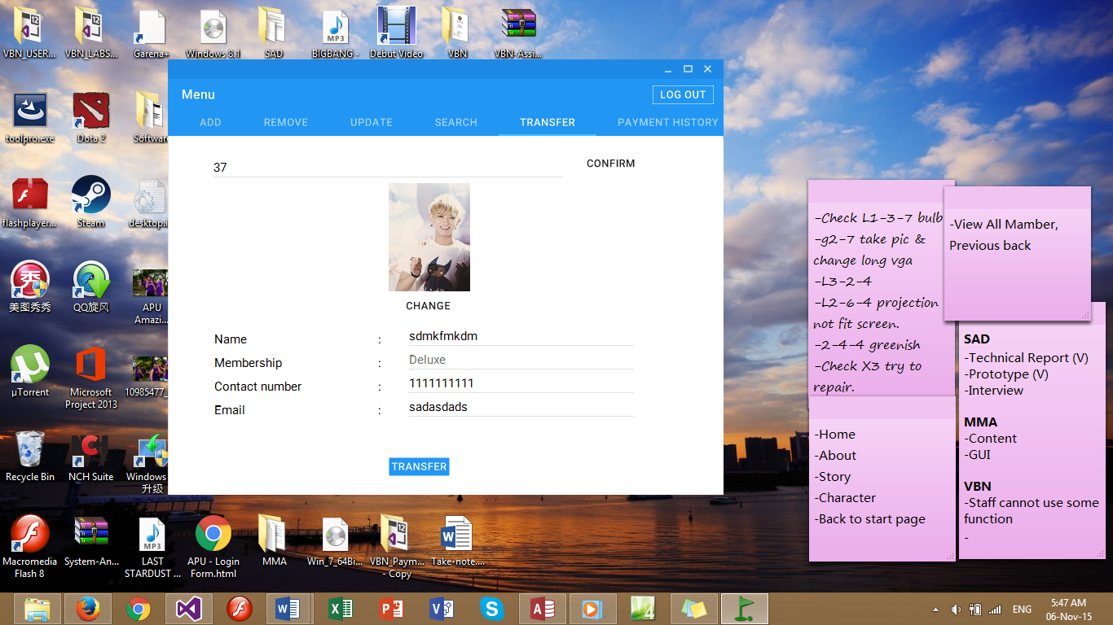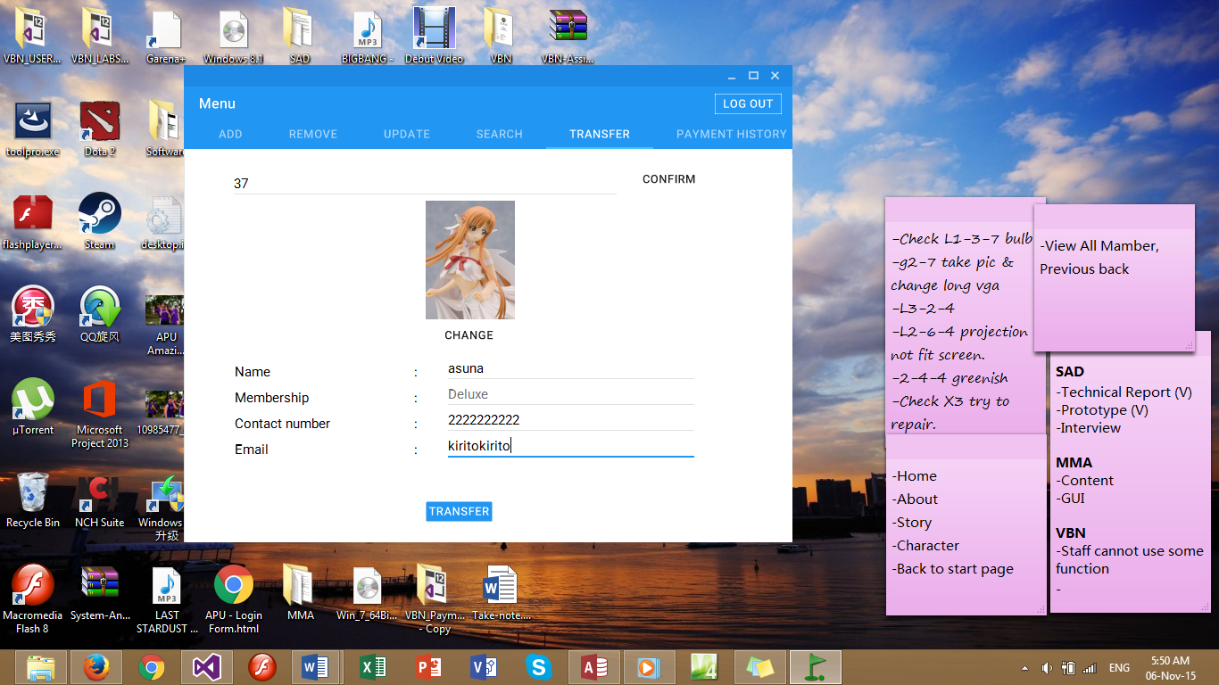

Transfer To

Customer A

Customer B

After done inserting the details, users will select “Transfer” button and the transferring will be done. When the transferring is successful, a message box will appear showing “Transfer!” as shown in the figure below.

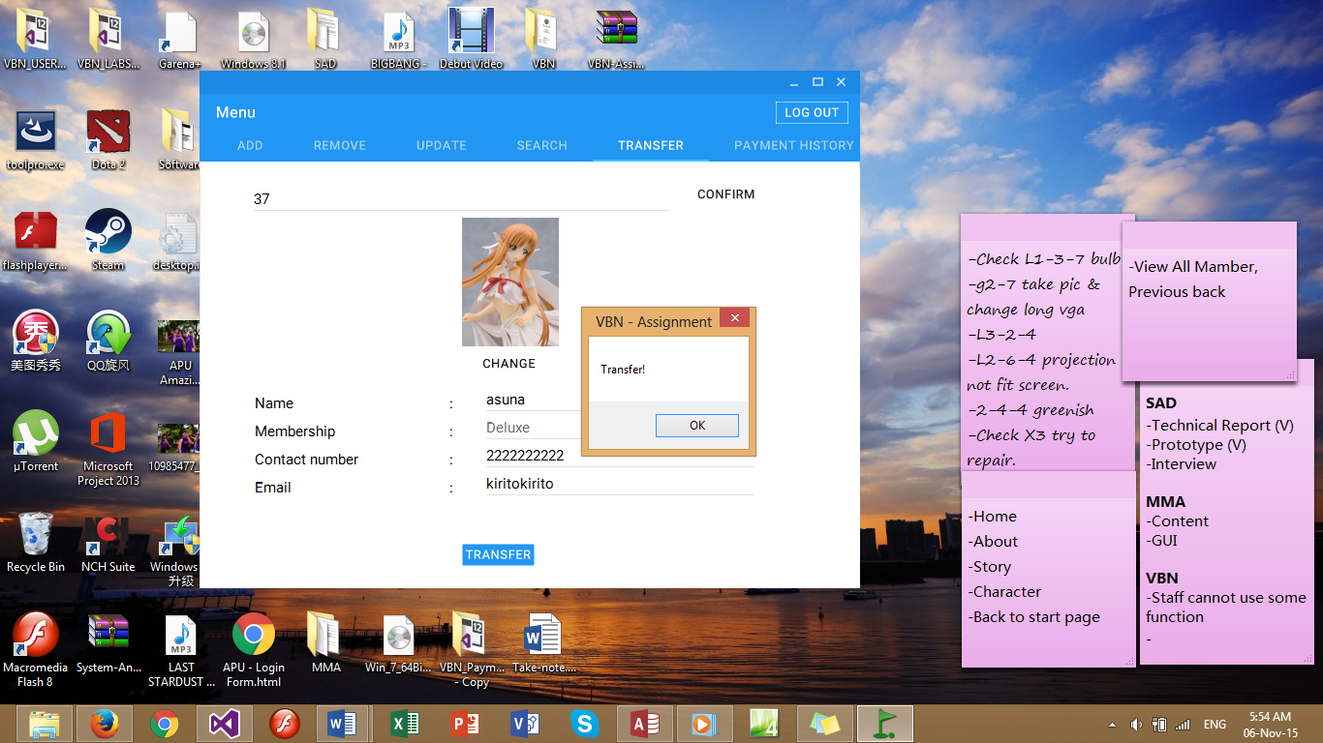

Meanwhile, when the transferring is successful, Customer A’s status will automatically change to “Closed” in the database. However, Customer B’s data will be updated in the database (as shown in the figure below).

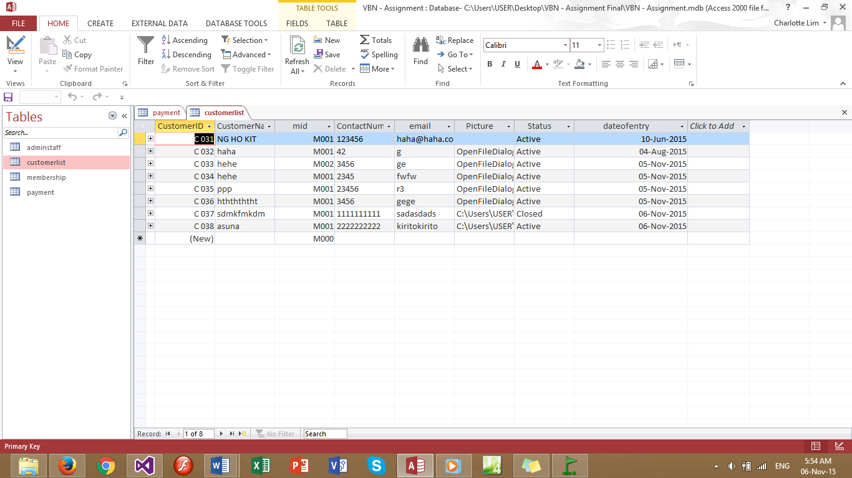

## 3.8 Menu - Payment History



Payment history allows the user to view the customer’s payment history. By inserting the customer’s id into the search textbox, then select “search” button. After selecting the “search button”, then the payment history will appear (as shown in the figure below).

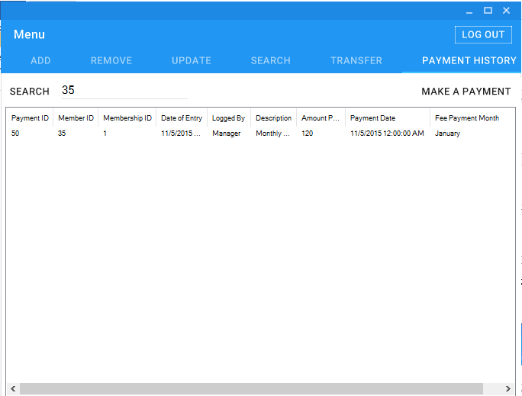

## 3.9 Make A Payment

When the customer wants to make a payment, user have to insert the customer’s id at the search bar in the “Payment History” form and select “Make a Payment” button (as shown in the figure below).



After selecting the “Make A Payment” button, a “Payment” form will appear. In the form, the customer’s details will be displayed such as Name, Member ID, Membership ID and Date of Entry. It also will display which user is logging into the system while serving the customer in making the payment.

Next, user has to select the type of fees at the description, depending on the customer on which type of payment they would like to pay (registration fee, monthly fee, and transfer fee). After selected the type of payment, “Amount Due” will display the amount that the customer have to pay. Then, the user have to insert the amount that the customer had paid into the “Amount Paid” box.

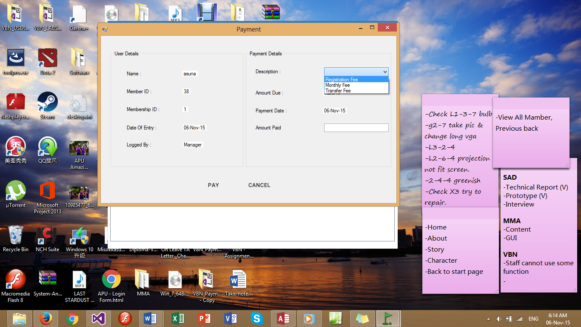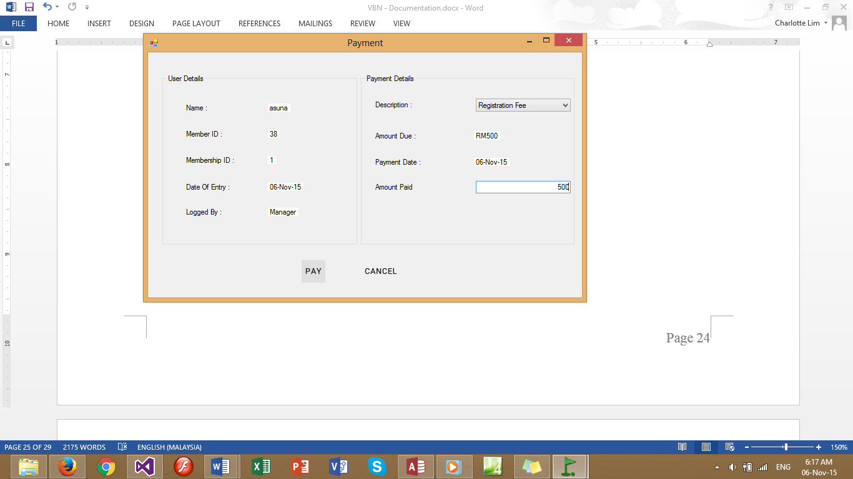

Amount Due Display

After done inserting the amount paid, user have to select “Pay” button in order to save the data into payment history database. When the payment is successful, a message box will appear showing “Paid!” (As shown in the figure below).

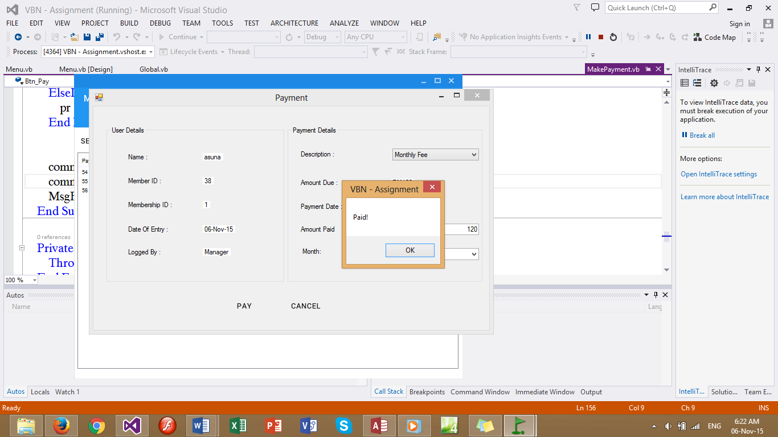

However, when the user select “Monthly Fee” in the combo box for the description, there will be a combo box appear as “Month”. User have to select the month of the monthly fees that the customer is paying for.



If the customer sudden change of mind and do not wish to pay, user can select “Cancel” button to cancel the payment and back to the menu page.

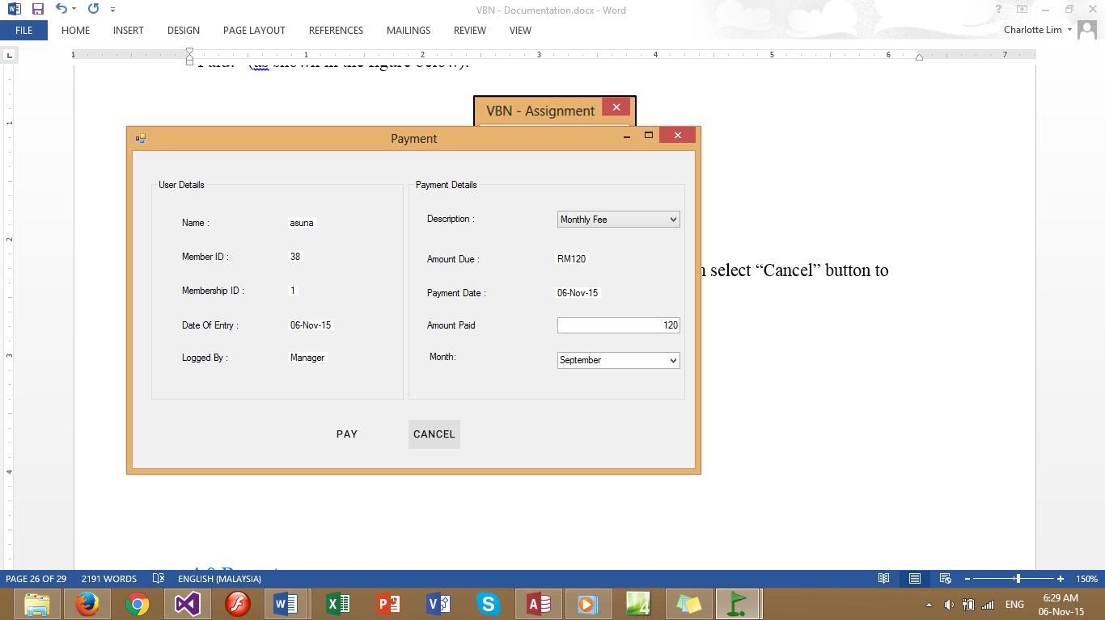

Back to Menu

In the database, will appear the new record of payment history.

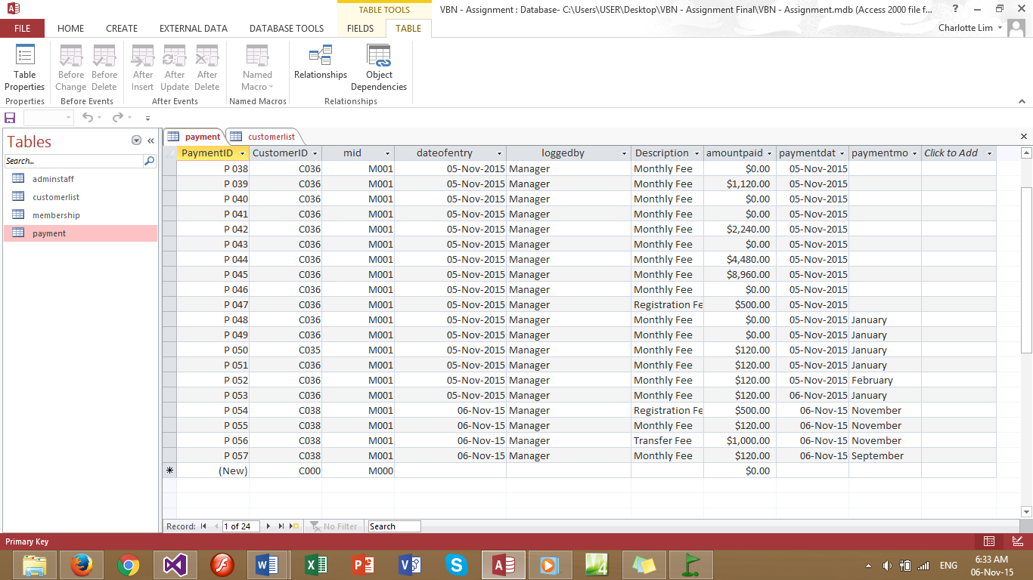

## 3.10 View All Member

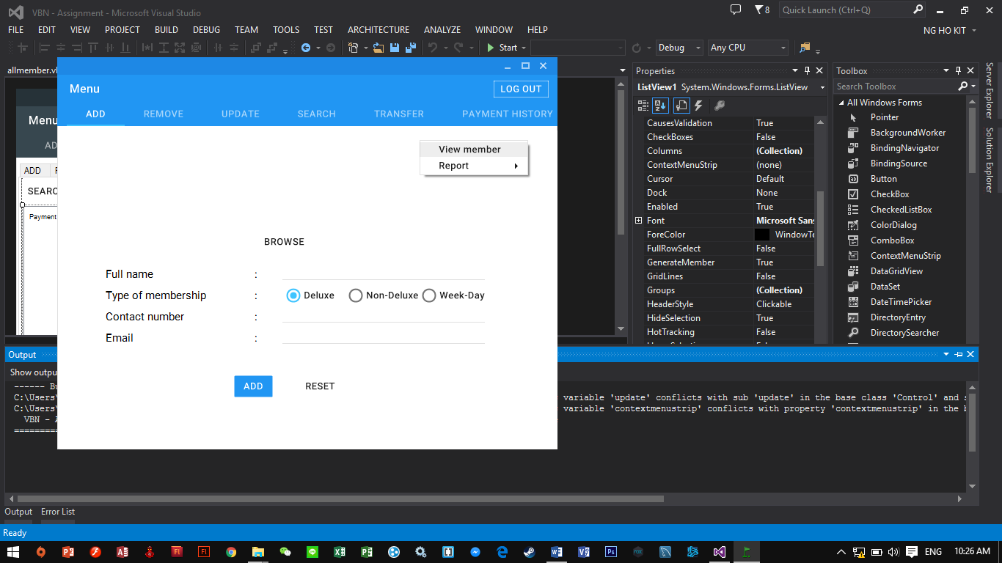

To view all members of the company, users can right click at the menu page. Then “View Member” option will appear as shown in the figure above. After selecting the “View Member” option, a form with all the member’s details is shown (as shown in the figure below).

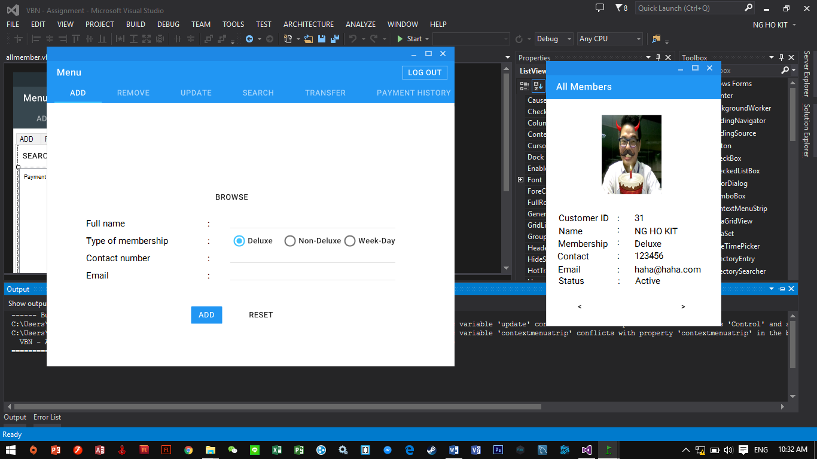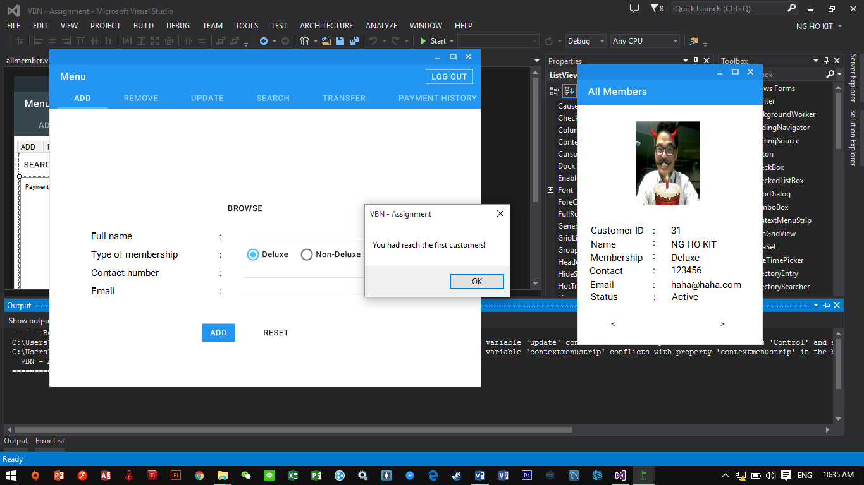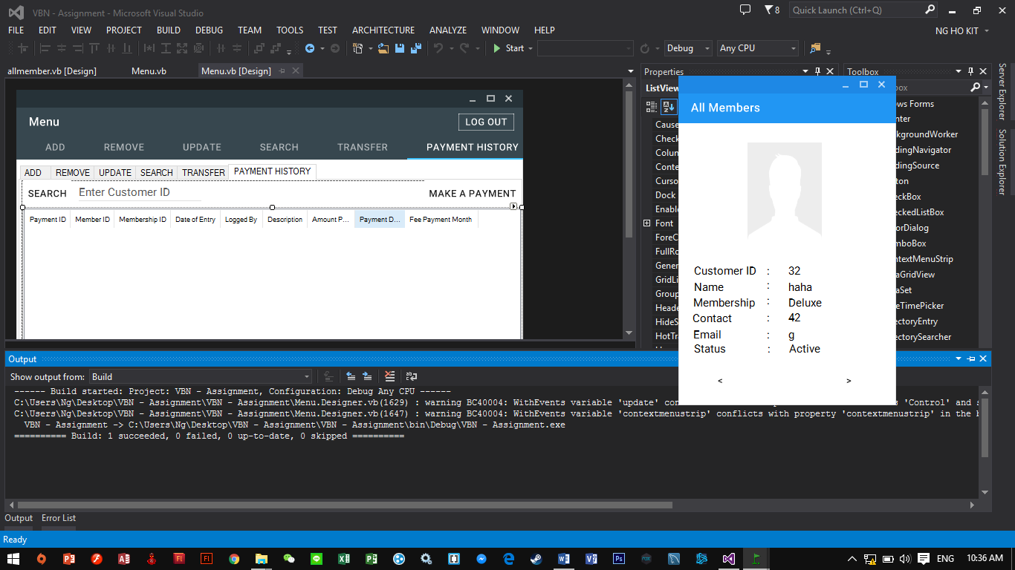

Right Arrow to Next User

Left Arrow to Previous User

When the All members form appear, there is Left button “<” and right button “>”. Left button is used to view previous customer’s details. Right button is to view the next customer’s details. When the page had reached the limit, a message box will appear and show “You had reach the first customer!”

## 3.11 Report

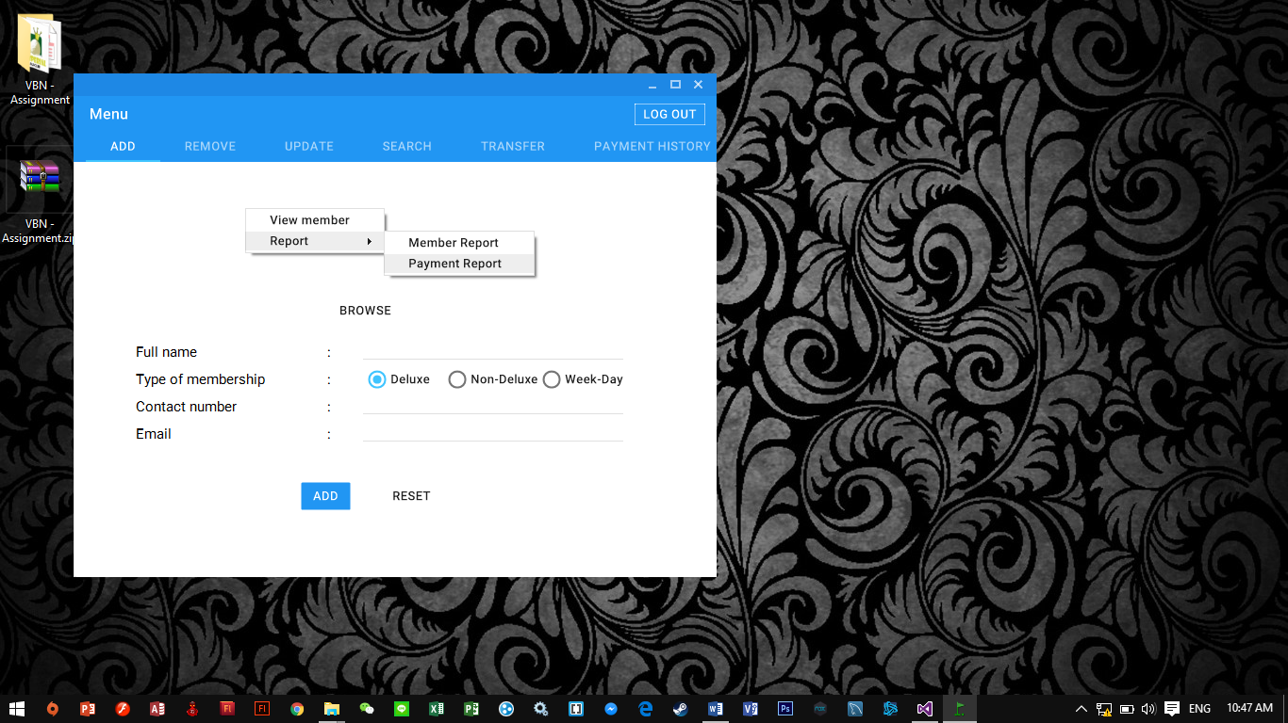

When users right-clicked at the menu page, there view be a “Report” option. When “Report” option is selected, user can select view either “Member report” or “Payment Report”.

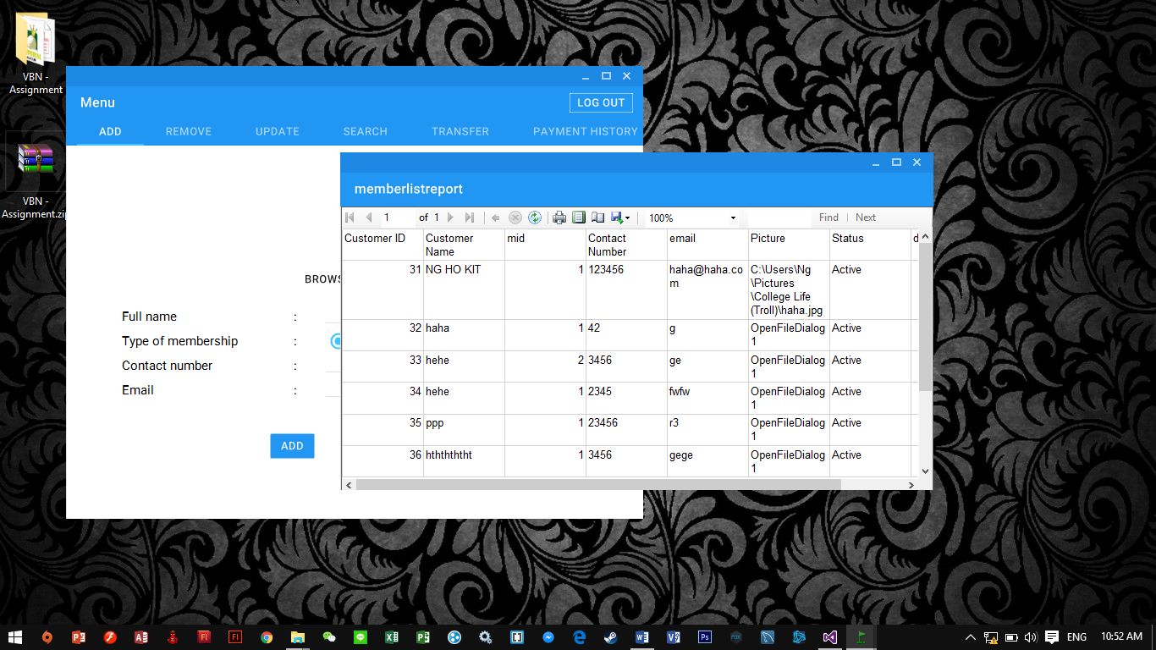Below are the example of Member report.

Below are the example of Payment Report.

# 4.0 Critical Assessment

## 4.1 Strength of Our System:

1. **More organize for administrators**

Administrators can manage the data of the customers very easily and more organized. Administrators can find the data of the customers just by several clicks on the system. This system have saved much time for the administrators.

1. **Input validation**

When inserting the data to the system there are validation such as alphabets characters are not allowed to input to “Contact Number”. Input validation is used to avoid wrong format of data are saved into database.

1. **User Friendly**

The system has a user friendly graphical user interface. It is easy to operate and the functions are easy to use. Thus, new administrator will be able to use the system without any special trainings.

## 4.2 Weakness of Our System:

1. **Unable to generate the monthly fees automatically.**

The system is unable to generate total monthly fees that a customer dues. Administrator have to check the description in the Payment History manually to ensure that the customers have paid their monthly fees.

1. **Security issues**

The database of the system is not secured. Thus other users can edit or retrieve the customer’s data easily.

1. **Only useable at one Local Machine.**

The system only able to use at one location which is only in one computer. It does not has online database system that allows administrator to record the data of customers at other location. Customers have to go to the main headquarters of the club in order to do the payments, register and close the membership.

1. **Auto Backup Issue**

The system does not have an auto backup function. Administrators have to do the backup manually and constantly.

## 4.3 Recommendations

In order to overcome the security issues of the database, the company can apply some passwords or third party software to “lock” the database. With this apply, only administrators are allowed to edit and view the database.

Next, the company can purchase a server to store the data into the server. At every location of the golf club will have one server which has the same network. Thus, customers do not have to go to the headquarter to register membership or do some payments. They can go to the golf clubs that are nearby and more convenience for them to do the payments, register memberships and data editing.

Lastly, to overcome auto backup issue, the system has to adjust the code at their database and their system.

# 5.0 References

Maes, I., 2014. *IgnaceMaes/ MaterialSkin.* [Online]   
Available at: https://github.com/IgnaceMaes/MaterialSkin  
[Accessed 4 November 2015].

Microsoft, 2015. *Msdn forums.* [Online]   
Available at: https://social.msdn.microsoft.com/Forums/en-US/home  
[Accessed 4 November 2015].

stackoverflow, 2015. *stackoverflow.* [Online]   
Available at: http://stackoverflow.com/  
[Accessed 4 November 2015].

tutorialspoint, 2015. *tutorialspoint.* [Online]   
Available at: http://www.tutorialspoint.com/vb.net/index.htm  
[Accessed 4 November 2015].

VBForums, 2015. *VBForums.* [Online]   
Available at: http://www.vbforums.com/  
[Accessed 4 November 2015].